The length of papers

- oral presentations: 4-6 pages.

- poster presentation: 2-6 pages

- SS session: 1-2 pages

English Title

Author Name*†, Membership Category of IEEJ, Author Name**, Membership Category of IEEJ

The quick brown fox jump over the lazy dog. The quick brown fox jump over the lazy dog. The quick brown fox jump over the lazy dog. The quick brown fox jump over the lazy dog. The quick brown fox jump over the lazy dog. The quick brown fox jump over the lazy dog. The quick brown fox jump over the lazy dog. The quick brown fox jump over the lazy dog. The quick brown fox jump over the lazy dog. The quick brown fox jump over the lazy dog.

**Keywords** : keyword1, keyword2

† Correspondence to: Taro Denshi. E-mail: TaroDenshi@iee.or.jp

* The quick brown fox jump over the lazy dog. Co., Ltd.  
0-0, Ichibancho, Chiyoda-ku, Tokyo, Japan 000-0000

1. Section

The quick brown fox jump over the lazy dog. The quick brown fox jump over the lazy dog. The quick brown fox jump over the lazy dog. The quick brown fox jump over the lazy dog. The quick brown fox jump over the lazy dog. The quick brown fox jump over the lazy dog. The quick brown fox jump over the lazy dog. The quick brown fox jump over the lazy dog. The quick brown fox jump over the lazy dog. The quick brown fox jump over the lazy dog. The quick brown fox jump over the lazy dog. The quick brown fox jump over the lazy dog. The quick brown fox jump over the lazy dog. The quick brown fox jump over the lazy dog. The quick brown fox jump over the lazy dog. The quick brown fox jump over the lazy dog. The quick brown fox jump over the lazy dog. The quick brown fox jump over the lazy dog. The quick brown fox jump over the lazy dog. The quick brown fox jump over the lazy dog. The quick brown fox jump over the lazy dog. The quick brown fox jump over the lazy dog. The quick brown fox jump over the lazy dog. The quick brown fox jump over the lazy dog. The quick brown fox jump over the lazy dog. The quick brown fox jump over the lazy dog. The quick brown fox jump over the lazy dog.

 (1)

The quick brown fox jump over the lazy dog. The quick brown fox jump over the lazy dog. The quick brown fox jump over the lazy dog. The quick brown fox jump over the lazy dog. The quick brown fox jump over the lazy dog. The quick brown fox jump over the lazy dog. The quick brown fox jump over the lazy dog. The quick brown fox jump over the lazy dog. The quick brown fox jump over the lazy dog. The quick brown fox jump over the lazy dog. The quick brown fox jump over the lazy dog. The quick brown fox jump over the lazy dog. The quick brown fox jump over the lazy dog. The quick brown fox jump over the lazy dog. The quick brown fox jump over the lazy dog. The quick brown fox jump over the lazy dog. The quick brown fox jump over the lazy dog. The quick brown fox jump over the lazy dog. The quick brown fox jump over the lazy dog. The quick brown fox jump over the lazy dog. The quick brown fox jump over the lazy dog. The quick brown fox jump over the lazy dog. The quick brown fox jump over the lazy dog. The quick brown fox jump over the lazy dog. The quick brown fox jump over the lazy dog. The quick brown fox jump over the lazy dog. The quick brown fox jump over the lazy dog. The quick brown fox jump over the lazy dog. The quick brown fox jump over the lazy dog.

2. Section

2.1 Subsection The quick brown fox jump over the lazy dog. The quick brown fox jump over the lazy dog. The quick brown fox jump over the lazy dog. The quick brown fox jump over the lazy dog. The quick brown fox jump over the lazy dog. The quick brown fox jump over the lazy dog. The quick brown fox jump over the lazy dog. The quick brown fox jump over the lazy dog. The quick brown fox jump over the lazy dog. The quick brown fox jump over the lazy dog. The quick brown fox jump over the lazy dog. The quick brown fox jump over the lazy dog. The quick brown fox jump over the lazy dog.

2.2 Subsection The quick brown fox jump over the lazy dog. The quick brown fox jump over the lazy dog. The quick brown fox jump over the lazy dog. The quick brown fox jump over the lazy dog. The quick brown fox jump over the lazy dog. The quick brown fox jump over the lazy dog. The quick brown fox jump over the lazy dog. The quick brown fox jump over the lazy dog. The quick brown fox jump over the lazy dog. The quick brown fox jump over the lazy dog. The quick brown fox jump over the lazy dog.

The quick brown fox jump over the lazy dog. The quick brown fox jump over the lazy dog. The quick brown fox jump over the lazy dog. The quick brown fox jump over the lazy dog. The quick brown fox jump over the lazy dog. The quick brown fox jump over the lazy dog. The quick brown fox jump over the lazy dog. The quick brown fox jump over the lazy dog. The quick brown fox jump over the lazy dog. The quick brown fox jump over the lazy dog. The quick brown fox jump over the lazy dog. The quick brown fox jump over the lazy dog. The quick brown fox jump over the lazy dog. (10)

Table 1. Table caption.

|  |  |  |  |  |
| --- | --- | --- | --- | --- |
|  |  |  |  |  |
| Table Strings |  |  |  |  |
|  |  |  |  |  |

Explanation of the table (if needed).

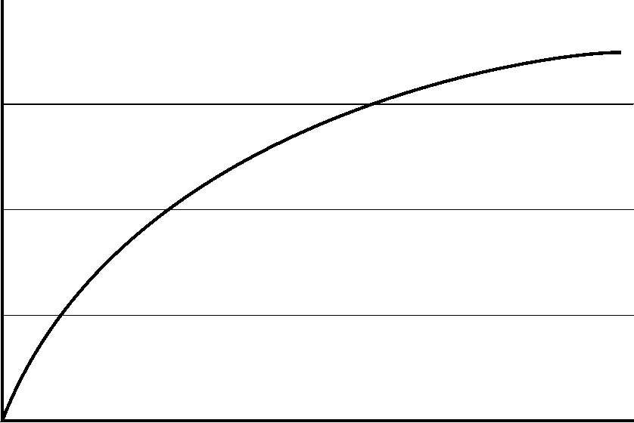

(a) Figure Sub caption



(b) Figure Sub caption

Fig. 1. Figure caption.

The quick brown fox jump over the lazy dog. The quick brown fox jump over the lazy dog. The quick brown fox jump over the lazy dog. The quick brown fox jump over the lazy dog. The quick brown fox jump over the lazy dog. The quick brown fox jump over the lazy dog. The quick brown fox jump over the lazy dog. The quick brown fox jump over the lazy dog. The quick brown fox jump over the lazy dog. The quick brown fox jump over the lazy dog. The quick brown fox jump over the lazy dog. The quick brown fox jump over the lazy dog. The quick brown fox jump over the lazy dog. (20)

The quick brown fox jump over the lazy dog. The quick brown fox jump over the lazy dog. The quick brown fox jump over the lazy dog. The quick brown fox jump over the lazy dog. The quick brown fox jump over the lazy dog. The quick brown fox jump over the lazy dog. The quick brown fox jump over the lazy dog. The quick brown fox jump over the lazy dog. The quick brown fox jump over the lazy dog. The quick brown fox jump over the lazy dog. The quick brown fox jump over the lazy dog. The quick brown fox jump over the lazy dog. The quick brown fox jump over the lazy dog. (30)

The quick brown fox jump over the lazy dog. The quick brown fox jump over the lazy dog. The quick brown fox jump over the lazy dog. The quick brown fox jump over the lazy dog. The quick brown fox jump over the lazy dog. The quick brown fox jump over the lazy dog. The quick brown fox jump over the lazy dog. The quick brown fox jump over the lazy dog. The quick brown fox jump over the lazy dog. The quick brown fox jump over the lazy dog. The quick brown fox jump over the lazy dog. The quick brown fox jump over the lazy dog. The quick brown fox jump over the lazy dog. (40)

The quick brown fox jump over the lazy dog. The quick brown fox jump over the lazy dog. The quick brown fox jump over the lazy dog. The quick brown fox jump over the lazy dog. The quick brown fox jump over the lazy dog. The quick brown fox jump over the lazy dog. The quick brown fox jump over the lazy dog. The quick brown fox jump over the lazy dog. The quick brown fox jump over the lazy dog. The quick brown fox jump over the lazy dog. The quick brown fox jump over the lazy dog. The quick brown fox jump over the lazy dog. The quick brown fox jump over the lazy dog. (50)

The quick brown fox jump over the lazy dog. The quick brown fox jump over the lazy dog. The quick brown fox jump over the lazy dog. The quick brown fox jump over the lazy dog. The quick brown fox jump over the lazy dog. The quick brown fox jump over the lazy dog. The quick brown fox jump over the lazy dog. The quick brown fox jump over the lazy dog. The quick brown fox jump over the lazy dog. The quick brown fox jump over the lazy dog. The quick brown fox jump over the lazy dog. The quick brown fox jump over the lazy dog. The quick brown fox jump over the lazy dog. (60)

The quick brown fox jump over the lazy dog. The quick brown fox jump over the lazy dog. The quick brown fox jump over the lazy dog. The quick brown fox jump over the lazy dog. The quick brown fox jump over the lazy dog. The quick brown fox jump over the lazy dog. The quick brown fox jump over the lazy dog. The quick brown fox jump over the lazy dog. The quick brown fox jump over the lazy dog. The quick brown fox jump over the lazy dog. The quick brown fox jump over the lazy dog. The quick brown fox jump over the lazy dog. The quick brown fox jump over the lazy dog.

The quick brown fox jump over the lazy dog. The quick brown fox jump over the lazy dog. The quick brown fox jump over the lazy dog. The quick brown fox jump over the lazy dog. The quick brown fox jump over the lazy dog. The quick brown fox jump over the lazy dog. The quick brown fox jump over the lazy dog. The quick brown fox jump over the lazy dog. The quick brown fox jump over the lazy dog. The quick brown fox jump over the lazy dog. The quick brown fox jump over the lazy dog. The quick brown fox jump over the lazy dog. The quick brown fox jump over the lazy dog.

The quick brown fox jump over the lazy dog. The quick brown fox jump over the lazy dog. The quick brown fox jump over the lazy dog. The quick brown fox jump over the lazy dog. The quick brown fox jump over the lazy dog. The quick brown fox jump over the lazy dog. The quick brown fox jump over the lazy dog. The quick brown fox jump over the lazy dog. The quick brown fox jump over the lazy dog. The quick brown fox jump over the lazy dog. The quick brown fox jump over the lazy dog. The quick brown fox jump over the lazy dog. The quick brown fox jump over the lazy dog.

The quick brown fox jump over the lazy dog. The quick brown fox jump over the lazy dog. The quick brown fox jump over the lazy dog. The quick brown fox jump over the lazy dog. The quick brown fox jump over the lazy dog. The quick brown fox jump over the lazy dog. The quick brown fox jump over the lazy dog. The quick brown fox jump over the lazy dog. The quick brown fox jump over the lazy dog. The quick brown fox jump over the lazy dog. The quick brown fox jump over the lazy dog. The quick brown fox jump over the lazy dog. The quick brown fox jump over the lazy dog.

The quick brown fox jump over the lazy dog. The quick brown fox jump over the lazy dog. The quick brown fox jump over the lazy dog. The quick brown fox jump over the lazy dog. The quick brown fox jump over the lazy dog. The quick brown fox jump over the lazy dog. The quick brown fox jump over the lazy dog. The quick brown fox jump over the lazy dog. The quick brown fox jump over the lazy dog. The quick brown fox jump over the lazy dog. The quick brown fox jump over the lazy dog. The quick brown fox jump over the lazy dog. The quick brown fox jump over the lazy dog.

The quick brown fox jump over the lazy dog. The quick brown fox jump over the lazy dog. The quick brown fox jump over the lazy dog. The quick brown fox jump over the lazy dog. The quick brown fox jump over the lazy dog. The quick brown fox jump over the lazy dog. The quick brown fox jump over the lazy dog. The quick brown fox jump over the lazy dog. The quick brown fox jump over the lazy dog. The quick brown fox jump over the lazy dog. The quick brown fox jump over the lazy dog. The quick brown fox jump over the lazy dog. The quick brown fox jump over the lazy dog.

The quick brown fox jump over the lazy dog. The quick brown fox jump over the lazy dog. The quick brown fox jump over the lazy dog. The quick brown fox jump over the lazy dog. The quick brown fox jump over the lazy dog. The quick brown fox jump over the lazy dog. The quick brown fox jump over the lazy dog. The quick brown fox jump over the lazy dog. The quick brown fox jump over the lazy dog. The quick brown fox jump over the lazy dog. The quick brown fox jump over the lazy dog. The quick brown fox jump over the lazy dog. The quick brown fox jump over the lazy dog.

The quick brown fox jump over the lazy dog. The quick brown fox jump over the lazy dog. The quick brown fox jump over the lazy dog. The quick brown fox jump over the lazy dog. The quick brown fox jump over the lazy dog. The quick brown fox jump over the lazy dog. The quick brown fox jump over the lazy dog. The quick brown fox jump over the lazy dog. The quick brown fox jump over the lazy dog. The quick brown fox jump over the lazy dog. The quick brown fox jump over the lazy dog. The quick brown fox jump over the lazy dog. The quick brown fox jump over the lazy dog.

References

(1) Author : “title”, journal title, Vol.00, No.000, pp.000-000 (pub. year)

(2) Author and Author : “title”, journal title, Vol.00, No.000, pp.000-000 (pub. year)

(3) Author, Author, and Author : “title”, journal title, Vol.00, No.000, pp.000-000 (pub. year)